Welcome to Route 3

2022 Spring Semester

Teachers and contact information:
Instructors’ names: | Suant Jane Sezgin | İrem Gedil
Email addresses: | jane.sezgin@sabanciuniv.edu | irem.gedil@sabanciuniv.edu
Zoom numbers: | 378 933 9264 | 402 253 3055
- Goals:
The goals of this course are:
- to develop your abilities to listen, read, write and speak fluently and accurately in English,
- to introduce you to academic skills needed for success at university,
- to help you use modern technological tools essential to university study, including word processing (e.g. Microsoft Word) and the Internet in an academically appropriate way,
- to develop your learning skills and your ability to study independently,
- to work collaboratively in groups to complete a variety of tasks.

Class times:
Your face to face and online lessons will be Mon - Fri 09:00-12:50. The schedule is as follows:
 | Monday | Tuesday | Wednesday | Thursday | Friday
F2F*:  9.00 – 9.50  OL**: | Suant Jane Sezgin  FENS L061 | İrem Gedil  FENS L063 | İrem Gedil  ONLINE | Suant Jane Sezgin  ONLINE | Suant Jane Sezgin  SOM G042
F2F:  10.00 – 10.50  OL: | Suant Jane Sezgin  FENS L061 | İrem Gedil  FENS L063 | İrem Gedil  ONLINE | Suant Jane Sezgin  ONLINE | Suant Jane Sezgin  SOM G042
F2F:  11.00 – 11.50  OL: | Suant Jane Sezgin  FENS L061 | İrem Gedil  FENS L063 | İrem Gedil  ONLINE | Suant Jane Sezgin  ONLINE | Suant Jane Sezgin  SOM G042
F2F:  12.00 – 12.50  OL: | Suant Jane Sezgin  FENS L061 | İrem Gedil  FENS L063 | İrem Gedil  ONLINE | Suant Jane Sezgin  ONLINE | Suant Jane Sezgin  SOM G042

If you join a lesson within the first two minutes, you will be marked ‘L’ (Late) and if you join after this time, you will be marked ‘A’ (Absent). If you have a valid medical report, you will be marked ‘MR’.

During Zoom lessons, your cameras and microphones must be turned on. If you wish, you can use a virtual background.

There are 20 hours per week of regular course work in total. You will also attend individual or group tutorials scheduled by your tutor. You’ll learn the name of your tutor in the first or the second week of the course.

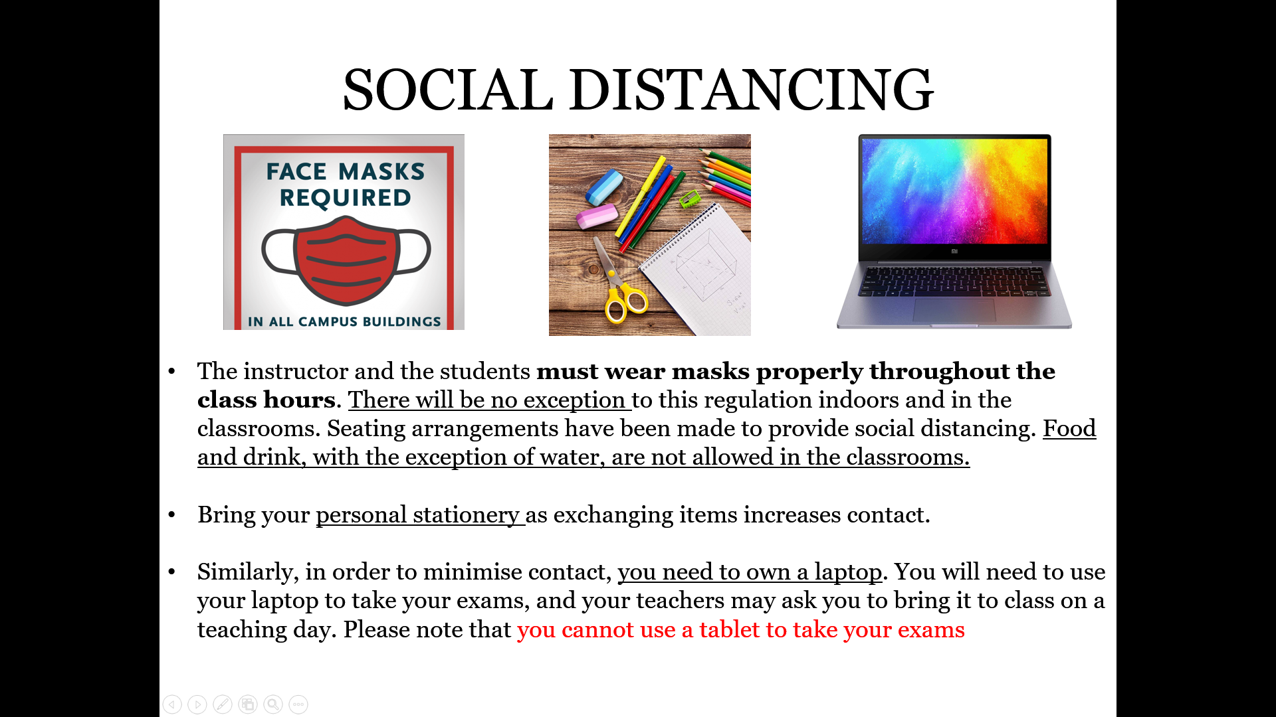

Things to buy and bring to your lessons*:
From Homer Bookshop online:

- Pathways 3 Reading and Writing and Critical Thinking
https://www.homerbooks.com/urun/pathways-reading-writing-and-critical-thinking
- Pathways 3 Listening and Speaking
https://www.homerbooks.com/urun/pathways-listening-speaking-and-critical-thinking
- Grammar and Beyond Essentials Level 3
https://www.homerbooks.com/urun/grammar-and-beyond-essentials-level-3-with-online-workbook
- Achieve 3000 16 Haftalık e-Paket
https://www.homerbooks.com/urun/achieve-3000-online-16-haftalik-e-paket

On SUCoursePlus:
1. Route 3 Teaching and Learning Programme (TLP),
2. Route 3 Learning Portfolio (LP),
3. Route 3 Word List,
4. Route 3 Supplementary Pack.
You should have your coursebook and other classroom equipment like the Teaching and Learning Programme (TLP), Word List, dictionaries, notebooks, and pen/pencils ready for each lesson.

Entire books cannot be photocopied under intellectual property law. Therefore, photocopies of course books and supplementary books will not be accepted. Sabancı University School of Languages has a zero tolerance policy in this area.

Dictionaries*:
Some suggestions for dictionaries are:
- Oxford Wordpower Dictionary (English-English)
- Collins Cobuild English Dictionary for Advanced Learners (English-English)
- Oxford English-Turkish Bilingual Dictionary
- Cambridge Learner’s Dictionary (English-Turkish)
- Oxford Learner's Wordfinder Dictionary (English-English)

You can also make use of the following online dictionaries and/or download the cell phone applications available for Merriam Webster, Cambridge, Longman, and Oxford dictionaries.
- Cambridge: http://dictionary.cambridge.org
- Longman: http://www.ldoceonline.com/dictionary
- Oxford: https://www.oxfordlearnersdictionaries.com/
- Macmillan: http://www.macmillandictionary.com
- Merriam-Webster: http://www.learnersdictionary.com/

*Online Turkish-English dictionaries like TurEng and Sesli Sözlük only provide the general meaning of words. Use dictionaries which give contexts, examples and explanations to help you study and learn to use vocabulary effectively.

- Achieve3000:

You will be reading articles from this platform throughout the semester. Your completion of these tasks will contribute to your HP (Homework and Participation) grade.

- Pathways LMS (Online Workbook) Self-Study

You will be doing activities from the Pathways 3 LMS (online workbook) throughout the semester. Your completion of these tasks might contribute to your HP (Homework and Participation) grade.

Vocabulary development
Make sure you use the vocabulary lists, word formation lists on SUCoursePlus effectively. They’re available at https://sucourse.sabanciuniv.edu/plus/. In addition, you may use books recommended by your teachers. You may also want to use the following for independent study:
- https://www.lextutor.ca/ (ask your teacher for information about how to use this site),
- English Vocabulary in Use: Intermediate with key, McCarthy & O’Dell,
- Test Your English Vocabulary in Use: Intermediate with key, Redman & Gairns,
- Visual thesaurus http://www.visuwords.com,
- For academic English words: http://www.englishvocabularyexercises.com.

- Grammar development

If you want to improve your grammar, you can buy a grammar book with answers and work on it in your own time. You may want to consider:
- English Grammar in Use (Raymond Murphy) which also has an app.
- TOP Grammar (R. Finnie, C. Frain, D. Hill and K. Thomas)

- Communication about the course:

You are required to check your e-mails from your teachers and from SUCourse+ regularly on a daily basis since you will most likely receive extra, essential and recent information concerning exams, lessons and homework in this manner. Not all e-mails come from individual teacher email accounts.

FREQUENTLY ASKED QUESTIONS

Will I have to do homework?
Definitely! Homework is an essential element of this course. You will be assigned homework which you should complete and hand in on time. You have to follow the deadlines set by your instructors. If you are ill, it is your responsibility to find out what the homework for that day is. If you can’t hand in your homework on time, contact the instructor and inform him/her of the situation.

To develop your English skills at Route 3, you will need to study about 3-4 hours a day outside online teaching hours; this involves homework and self-study of vocabulary, grammar, as well as, other reading and listening tasks.

What are tutorials? What types of tutorials are there and what are they for?
You are going to have individual or group tutorials at this route. They are a very important part of the course as your tutor can provide you with feedback and can track your progress in writing and speaking. You’ll arrange the time of the tutorial with your tutor. There are three main types of tutorials:

- Getting-to-know-you / Goal Setting Tutorials: These are an opportunity for your tutor to get to know you personally at the beginning of the semester.
- Writing Tutorials: These are to discuss your short and long writing assignments. They are an opportunity for you to check you understand the written feedback your teacher has given you, as well as to check that your ideas about corrections or changes to your writing are OK. To benefit properly from these tutorials, make sure you note down any questions that you want to ask to your tutor and you must prepare by reading, thinking about and acting on the feedback your tutor gives you.
- Portfolio and Progress Tutorials: In this tutorial you will share your reflections about the process of collecting your written work and your improvement in writing skills over a period of time.
- Who can I talk to if I can’t cope with studies because of personal, family or health problems?
We have professional student counsellors (BADA) in CIAD (Center for Individual and Academic Development) or in Turkish BAGEM (Bireysel ve Akademik Gelişim Merkezi). You can contact them whenever you have a problem which affects your studies or/and your private life. You can get an appointment by sending an email to https://abidp.simplybook.me/sheduler/manage. You may get further information on their work from the Student Handbook.

- How can I practice my English speaking skills outside the classroom?
The aim of the Language & Culture Exchange Project is to connect individuals who wish to practice and improve their foreign language speaking skills. Join them if you wish to practice your English speaking skills.

ROUTE 3 ASSESSMENT SCHEDULE, Spring 2021-2022
During the Route 3 course, students are assessed by ongoing evaluation and exam-based assessments. To be able to move to Route 4, a student must attain a grade of 70% from the course assessments during the semester. If you score lower than 69.45%, you will continue to study in the School of Languages in Fall, 2022.
Your exams will be online and face-to-face.
The assessment for Route 3 course is a combination of assessed coursework and exams.
Assessed Coursework

Attendance | 6% (given 3 times - 2% each) | Attendance and Punctuality: coming to all lessons & tutorials regularly on time
HW and Participation | 6% (given 3 times)  HP1 - 2% Week 5  HP2 - 3% Week 10  HP3 - 3% Week 15 | Homework: Satisfactorily completing all tasks on time.  Class Participation: making an effort in class and speaking in English almost all the time; being actively involved in the tasks and completing them at an acceptable level of quality.
Collaborative Learning | 5 % | You will be completing a total of four tasks in groups of three or four. You will need to do extensive reading, writing and speaking in order to complete your tasks. Your contribution to the tasks and the finalized tasks will be evaluated separately.
Oral Assessment | 18%  OA 1 - 8% April 13 & 14  OA 2 - 10% June 15 & 16 | You will be assessed on your spoken language, fluency, idea development and interaction skills through group discussion. OA 1 will test your ability to take part in a group discussion. In OA 2, you will be tested in an individual interview.
Learning  Portfolio | 8% given twice (4% each)  LP1 - Week 7  LP2 - Week 14 | You will be evaluated on your portfolios. Before the evaluation, you will be asked to select a specific number of tasks that reflect your good work and progress. You will complete self-reflection tasks, set learning goals and attend tutorials to discuss your progress and reflections before the evaluation.
Short Answer Exam | 10% April 20 | For this exam, you will write one short response between 120-150 words based on two texts. The texts will be closely related to the topics you studied in class. You will need to take notes from both of these texts and then use your notes to answer a prompt.
Open Book Exam | 13% June 7 | For this exam, you will receive some exam texts around a week before the exam. After reading them at home and working on them in and outside class, you will take your Open Book Exam. You will be given a new copy of the OBE Text Pack in the exam room and will write a piece of work (350-450 words) using the information in the exam texts.
Midterm Exam | 10% April 26 | This exam will assess the vocabulary & grammar you have covered during the first half of the course.
Final Exam | 24% June 23 | This exam will assess the reading and listening skills you have been working on as well the vocabulary & grammar covered during the course. You will read a text and answer related questions. You will listen to two recordings (one note-taking and one while-listening) in the form of an interview/ lecture and answer related questions.
IMPORTANT: AUTHENTICATION INTERVIEWS & TASKS

Please be informed that SL may conduct an authentication interview or require completion of additional authentication tasks to assess the authenticity of a submitted work including exams. If a student objects to take place in the interview or carry out the tasks, they agree to get 0 (zero) from their assessed work.

IMPORTANT
HEALTH REPORT AND THE EXAM DAY
In case you are unable to take any of the exams, or if you miss a portfolio task for health reasons, it is important that you follow the rules below in order to be able to take a makeup exam (See Student Handbook)
English version: https://sl.sabanciuniv.edu/sites/sl.sabanciuniv.edu/files/school_of_languages_handbook_2020-21_.pdf
Turkish version:
https://sl.sabanciuniv.edu/sites/sl.sabanciuniv.edu/files/diller_okulu_el_kitabi_2020-21.pdf

1. Contact the main instructor of your class either through e-mail or by telephone 1 day before the exam at the latest; or for urgent, unpredictable situations, and if you are only able to call on the day of the exam, please telephone the Administrative Office of the School of Languages (phone number: 216 4839739, extension: 9150).
2. If you reside on campus, please seek necessary medical treatment at the University Health Centre, you can access their contact information at https://www.sabanciuniv.edu/en/health-center, and obtain a health report from them. They will inform the instructor of your course through e-mail.
3. If the medical report is obtained from a medical institution other than the Sabancı University Health Centre, it has to be approved by the doctors at the University Health Centre within 3 working days following the end of the medical report. During the online education period due to the pandemic, the medical reports obtained from a medical institution other than the Sabancı University Health Centre have to be sent to Sabancı University Health Centre by email. When the medical report is approved, students do not need to take any other action since SU Health Centre informs the class instructors about the approval of the medical report by email. However, if there is an FDY exam on the days when the student has a medical report approved by SU Health Centre, a make-up petition form which can be obtained from the photocopy centre or Route SucoursePlus during online education should be given or emailed to SL Administrative Office within 3 working days following the end of the medical report. (E.g. If the medical report expires on Tuesday, the deadline to hand in the petition to SL Administrative Office is Friday by 5 p.m.)
STATEMENT OF ACADEMIC INTEGRITY
Learning a language is enhanced through cooperation and interaction and as such you are encouraged to work in groups, ask for and give help freely in all appropriate settings. However, all work that you submit to your instructors (homework assignments, in-class assignments, exams, presentations, etc.) should conform to the standards of academic integrity. Any work that is submitted should be your original piece of work, presenting your ideas in your own words. If you are asked to refer to books, articles, or web sites in your work, they should be properly cited following the guidelines. Although you are encouraged to discuss your ideas with others (including your classmates), it is important that you do not share your work (presentation slides, MS Word files, Google Docs, recordings, etc.) with anyone, or ask for theirs.

Using someone else’s ideas or information in your work without indicating the source; using someone else’s language; inventing data to support your ideas are considered plagiarism. Copying from others or providing answers or information, written or oral, to others, having your assignment done by somebody else; or doing somebody else’s assignment is cheating. These are considered serious academic offences, and any suspected examples of these infringements will be examined by committees of instructors and may result in penalties ranging from loss of grades to referral to the SL Academic Integrity Group or university disciplinary board. Please pay utmost attention to avoid such accusations. In addition, if deemed necessary, students might be called to carry out authentication tasks and/or interviews randomly or if there is any suspicion of infringement of academic integrity. In such cases, the grade received from the authentication task is valid.

SCHOOL OF LANGUAGES ANTI-DISCRIMINATION POLICY
As the School of Languages, we will not ignore any attitude, statements or behaviour containing violence, humiliation or discrimination with regard to:
- sex
- sexual orientation
- gender, gender identity or gender expression
- ethnicity
- national background
- language
- religion
- physical or mental ability
- social class
- physical appearance
- marital or parental status
- age
- political affiliation

We expect all School of Languages members, students, academic and administrative personnel, to act according to this ethical principle.

If you experience or witness any such behaviour, you can contact:
Pınar Demiral Gündüz
Room: SL 1007
Tel: 9741
Email: pgunduz@sabanciuniv.edu
The work/information laid out in this calendar/ document might be changed and / or revised based on current circumstances

