Gender and Work – Syllabus / Summer 2021
Wednesdays and Thursdays, 16.40-19.30

E. İrem Az Teaching Assistant Gaye Kuas
irem.az@sabanciuniv.edu gaye.kuas@sabanciuniv.edu
eia2109@columbia.edu Discussion section: TBA
Student/office hours: by appointment

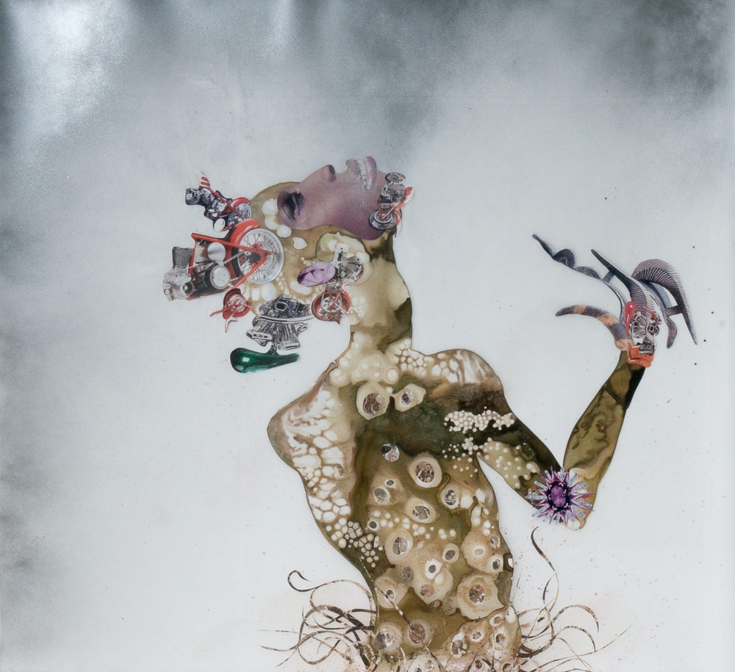

Wangechi Mutu, Living Through Strange Times (detail), 2004.
Ink, paint and collage on Mylar. Upper; 46 x 49 in., Lower; 37 x 43 in.
© Wangechi Mutu, courtesy Gladstone Gallery, New York and Brussels.
Linda Pace Foundation Collection, Ruby City, San Antonio, Texas.

Course description

- Do you work?
- No, I’m a housewife.
- I thought you also worked in the fields?
- Ah, yes, I go to the fields.

—extract from a conversation with Güler,
who works in her house, and in agriculture as a daily field laborer,
in Kınık, İzmir (2018)

In a world of intensifying inequalities and indebtedness, the problem of work has long been vital for many contemporary communities. Human beings all around the world work on their intimate relationships, on themselves; they work for a wage, and/or for the maintenance and elevation of the lives of others. This course attends to the multiplicity of contemporary labor regimes and understandings of work by problematizing the meanings, functions, capabilities and materialities that are attributed to different categories of “gender.” To do so, we will take a wide approach to “gender,” putting it into conversation with class, ethnicity and race, queerness, nation, and migration. We will thus learn from a variety of situated perspectives that are comparativist by nature, always considering the conditions of the intensifying neoliberal moment.

What is work and/or labor—and what is the difference between the two, if there is a difference at all—in relation to gender? How does “gender” matter at work, and in what ways does it affect when, where and how one works? How does “gender” shape one’s capacity, obligation and desire to be productive in the world through work? How do experiences of work shape one’s experiences of being, or not being gendered? By paying particular attention to what kinds of and whose labor count as “real work,” we will seek answers to these questions as well as new questions. We will thus focus on the types and experiences of work that are ignored, invisibilized, informalized, and workers who are excluded from certain spheres of social and political life, or violently included in certain other spheres. We will also consider international and local social movements and forms of resistance, such as Wages for Housework, and living wage ordinances. Finally, we will heed the call of scholars and activists who imagine a postcapitalist and postwork world—and we will end the course hopefully by conceiving new questions about the links between work, postwork imaginaries, and a world without an essentialized gender binary.

You should leave this seminar with an understanding of work and labor in its situated and globalized forms, and of the multifaceted ways in which gendered processes and becoming gendered as a process are integral to the way we understand and hope to understand work.

Assignments and grading

Your course grade will be determined as follows:

1. Attendance*, participation**, and one article presentation*** – 20%
*Only 3 excused absences are allowed. You should inform me and your assistant before or—if it is an emergency—after the session as to why you missed the session. If you miss more than three sessions, your final grade will be deducted by 25 points.
**For participation guidelines, please see the section on attendance and participation below in the Policy Sheet.
***For your presentation, you can choose one of the articles and book chapters highlighted in gray. These presentations should be prepared as conversation starters, and ideally end with a few questions to be discussed in class. The length of presentations should be around 15 minutes.

2. Discussion posts* (8 posts x 3 points each) – 24%
*300 words due at 1 pm before each session. You will see 11 discussion post assignments on Top Hat, and you are required to post for 8 sessions of your choice. The discussion posts are for you to learn more actively by reflecting briefly on the readings each week, to prepare to contribute to our in-class discussion, and to have as many chances as possible to share glimpses of your learning processes/processes of engagement with the assigned texts with me and with each other. Please take the 300-word limit seriously so that we can all read each other’s posts before the class.

3. Annotated open-ended interview questions and bibliography for the final paper* (3-4 pages).
– 20%
*The details of this assignment, and the final paper will be shared in the first class.

4. Final paper* (~10 pages / 4000 words min) – 36%
*Based on the interview(s) conducted with one or two workers, or on your own experience.

The due dates are subject to change with advance notice. Discussion postings and papers are due online before the beginning of that week’s class. Unless you have made prior arrangements with me, late work will be penalized by a half-letter grade deduction if you submit in the same day, and by a full letter grade deduction if you submit later in the same week.

Written assignment formatting

All written assignments (except for Discussion Postings, which you will submit through the online system) must be formatted as follows: Times New Roman 12-point font, double-spaced, page numbered, 1-inch margins.

Note that the readings are subject to change, with a reasonable amount of forewarning.

Week 1: THE SECRET OF WORK

- Session: Thursday, July 1

Course overview and logistics.

Please watch before class:

Tadiar, Neferti X. M. “The Human Question” – 2009 Duke Feminist Theory Workshop Keynote Address (55 minutes long):
https://www.lowendtheory.org/post/1418222950/neferti-tadiar-the-human-question-duke

- Session: Wednesday, July 7

Terkel, Studs. 1974. “DOLORES DANTE,” “THERESE CARTER,” “JESUSITA NOVARRO.” In Working: People Talk About What They Do All Day and How They Feel About What They Do. New York and London: The New Press.

Marx, Karl. “Chapter 10: The Working Day.” In Capital Volume 1. Penguin Classics, 340-416.

Duffy, Mignon. 2007. “Doing the Dirty Work: Gender, Race, and Reproductive Labor in Historical Perspective.” Gender and Society 21(3), 313-336.

Suggested:

Calvão, Filipe. 2016. “Unfree Labor.” Annual Review of Anthropology (45): 451-462.

Rosalind C. Morris. 2016. “Dialect and Dialectic in ‘The Working Day’ of Marx’s Capital.” boundary 2 (February 1) 43(1), 219-248. doi: https://doi.org/10.1215/01903659-3340709.

Week 2: WORK AND LABOR

- Session: Thursday, July 8

Arendt, Hannah. 2003[1964]. “Labor, Work, Action”, in The Portable Hannah Arendt, pp. 167-181.

Comaroff, Jean, and John L. Comaroff. "The Madman and the Migrant: Work and Labor in the Historical Consciousness of a South African People." American Ethnologist 14, no. 2 (1987): 191-209. Accessed April 20, 2021. http://www.jstor.org/stable/645369.

- Session: Wednesday, July 14

Glenn, Evelyn Nakano. 1992. “From Servitude to Service Work: Historical Continuities in the Racial Division of Paid Reproductive Labor.” Signs 18(1), 1992: 1-43.

Mills, Mary Beth. 2003. “Gender and Inequality in the Global Labor Force.” Annual Review of Anthropology 32: 41-62.

Çelik, Coşku and Ecehan Balta. 2017. “Soma Havzasında Görünmeyen Emek: Kadın[Invisible Labor in Soma coal basin: Women].” Ayrıntı Dergi, 27 March. https://ayrintidergi.com.tr/soma-maden-havzasinda-gorunmeyen-emek-kadin/.

Suggested:

Vicki Smith, “Braverman’s Legacy: The Labor Process Tradition at 20,” Work and Occupations 21(4), 1994: 403-421.

Firth, Raymond. 1979. “Work and Value: Reflections on Ideas of Karl Marx.” In Social Anthropology of Work, edited by Sandra Wallman. Academic Press, 177-199.

Thursday, July 15, 2021 – National Holiday

20-23 July, 2021 – Religious Holiday

Week 3: GENDER AT WORK, BODIES IN SPACE

- Session: Wednesday, July 28

Besky, Sarah. 2014. “Chapter 2: Plantation.” In The Darjeeling Distinction: Labor and Justice on Fair Trade Tea Plantations in India. University of California Press, 59-87.

Avcı, Bekir. 2020. “Söyleşi: Ölülerimizle, dirilerimizle toplandık, birlikte mücadele ediyoruz [We are here with our living and our dead, resisting together.” birartibir.org, October 14. https://www.birartibir.org/emek/894-olulerimizle-dirilerimizle-toplandik-birlikte-mucadele-ediyoruz.

Kang, Miliann. 2003. “The Managed Hand: The Commercialization of Bodies and Emotions on Korean-Immigrant-Owned Nail Salons.” Gender and Society 17(6): 820-839.

Suggested:

Duruiz, Deniz. 2015. “Chapter 12: Embodiment of space and labor: Kurdish migrant workers in Turkish agriculture.” In The Kurdish Issue in Turkey: A Spatial Perspective. London: Routledge, 289-308.

Federici, Sylvia. 2014[Originally published in 2004]. “The Accumulation of Labor and the Degradation of Women: Constructing ‘Difference’ in the ‘Transition to Capitalism’.” In Caliban and the Witch – Women. the Body and Primitive Accumulation. New York: Autonomedia, 61-131.

- Session: Thursday, July 29

Please watch before class: I, Daniel Blake (2016), Director: Ken Loach.

Steedman, Carolyn Kay. 1987. Landscape for a Good Woman: A Story of Two Lives. New Brunswick, NJ: Rutgers University Press, 1-62, 83-97.

Suggested:

Novel: Louis, Edouard. 2018. Who Killed My Father, translated from French by Lorin Stein. New Directions.

Podcast: On Being with Krista Tippett (March 11, 2021): “937. Ocean Vuong – A Life Worthy of Living” (50:49). (Available at Apple Podcast and Spotify)

Podcast: K’nın Sesi, “Oyun #4: “Bir Diyeceğim Var” (9:44) ve “Sohbet #4: Kadınların ‘İşgücü’ne Katılımı” (38:20). (Available at Apple Podcast and Spotify).

Villarreal, Ana T. 2010. “The Bus Owner, the Bus Driver, and His Lover: Gendered Class Struggle in the Service Work Triangle.” Work and Occupations 37(3): 272-294.

Week 4: DOMESTIC WORK, RACE, AND LIFE

- Session: Wednesday, August 4

Please watch before class: The Second Mother (Documentary, 2015), Director: Anna Muylaert

Luxembourg, Rosa. 2003[1913]. “26 – The Reproduction of Capital and Its Social Setting.” In The Accumulation of Capital. London and New York: Routledge Classics, 328-347.

Tadiar, Neferti X. M. "Life-Times of Becoming Human." Occasion: Interdisciplinary Studies in the Humanities v. 3 (March 1, 2012):
https://arcade.stanford.edu/occasion/life-times-becoming-human

Cortés, Luba. 2016. “My Undocumented Mom, America’s Housekeeper.” The New York Times. June 23.

https://www.nytimes.com/2016/06/24/opinion/my-undocumented-mom-americas-housekeeper.html.

Suggested:

YouTube Video: “Understanding Rosa Luxemburg’s Life and Work | Peter Hudis.” Verso Books, March 5, 2020.

(An interview with Peter Hudis, editor of Complete Works of Rosa Luxemburg, in cooperation with the Rosa-Luxemburg-Stiftung)

Carrillo, Teresa. 2014. “Translation and Transnationalization of Domestic Service." In
Translocalities/Translocalidades: Feminist Politics of Translation in the Latin/a Américas, edited by Sonia E. Alvarez, et al. Durham, NC: Duke University Press.

- Session: Thursday, August 5

Dill, Bonnie Thorton. 1994. “Chapter Four: Work and Personal Dignity.” Across the Boundaries of Race and Class: An Exploration of Work and Family Among Black Female Domestic Servants. New York: Garland, 83-106.

Casanova, Erynn Masi de. 2013. “Embodied Inequality: The Experience of Domestic Work in Urban Ecuador." Gender and Society 27(4): 561–585.

Parreñas, Rhacel Salazar. 2015[2001]. “Chapter 6: The Crises of Masculinity.” In Servants of Globalization: Women, Migration, and Domestic Work. Palo Alto, CA: Stanford University Press, 159-182.

Week 5: SEX WORK, MILITARY WORK, AND AN ANTI-ESSENTIALIST MATERIALITY

- Session: Wednesday, August 11

Please watch before class: Jeanne Dielman, 23 Commerce Quay, 1080 Brussels (1975), Director: Chantal Akerman.

Bras, Patricia Sequeira. “Time and Reproductive Labor in Jeanne Dielman, 23 quai du Commerce, 1080 Bruxelles (1975) and Three Sisters (2012). Parse Journal Vol. Work(9). https://parsejournal.com/article/time-and-reproductive-labour-in-jeanne-dielman-23-quai-du-commerce-1080-bruxelles-1975-and-three-sisters-2012/. ISSN (Online): 2002-0953. Publisher: University of Gothenburg.

Zengin, Asli. 2020. “A Field of Silence: Secrecy, Intimacy, and Sex Work in Turkey.” Feminist Studies 46(2), 345-370.

Berg, Heather. 2014. “Working for Love, Loving for Work: Discourses of Labor in Feminist Sex-Work Activism.” Feminist Studies 40(3): 693-721.

- Session: Thursday, August 12

Bickford, Andrew. 2019. “Section II. Military Labor.” In Militarization: A Reader. Durham, NC: Duke University Press, 57-58.

Bailey, Beth. 2019. “Soldiering as Work: The All-Volunteer Force in the United States.” In Militarization: A Reader. Durham, NC: Duke University Press, 59-61.

Floyd, Kevin. 2009. “Performative Masculinity: Judith Butler and Hemingway’s Labor Without Capital.” In The Reification of Desire: Toward a Queer Marxism. Minneapolis, MN: University of Minnesota Press, 79-119.

Week 6: POST-WORK? POST-GENDER? THE FUTURES OF WORK AND GENDER

- Session: Wednesday, August 18

Morris, Rosalind C. “All Made Up: Performance Theory and the New Anthropology of Sex and Gender.” Annual Review of Anthropology, 1995, Vol. 24 (1995), pp. 567-592. https://www.jstor.org/stable/2155950.

Wajcman, Judy. 2015. “Chapter 5: Doing Domestic Time.” In Pressed for Time: The Acceleration of Life in Digital Capitalism. Chicago, IL: University of Chicago Press, 111-135.

- Session: Thursday, August 19

Weeks, Kathi. 2011. “Working Demands: From Wages for Housework to Basic Income.” In Feminism, Marxism, Antiwork Politics, and Postwork Imaginaries. Durham, NC: Duke University Press, 113-150.

Srnicek, Nick and Alex Williams. 2015. “Postwork Imaginaries.” In Inventing the Future: Postcapitalism and a World Without Work. New York and London: Verso Books.

Kim, Tammy. 2015. “Organizing the Unorganizable.” Dissent 62(2): 59-64.

Suggested:

Irene Weipert, Irene, and Jonas Wolff. 2016. “Unemployed Movements in the
Global South: The cases of Argentina and Tunisia.” Working Paper Series.

Policy Sheet

Attendance, lateness and absences

Please come to all classes. If you know you must miss a particular number of classes because of a planned event such as a religious observance, an out-of-town conference, or another legitimate reason, let me know ahead of time. If you are sick or it is another emergency, let me know as soon as you can. Following an absence, it is your responsibility to get class notes from a classmate.

Only 3 excused absences are allowed. You should inform me and your assistant before or—if it is an emergency—after the session as to why you missed the session. If you miss more than three sessions, your final grade will be deducted by 25 points.

Participation, speaking-in-class (anxiety) and student/office hours

This course has a seminar format, relying primarily on our in-class, active learning-centered discussions. But participation does not only mean in-class verbal contribution to discussions. Though I highly encourage that you share your thoughts and comments on the course material in class, I appreciate different ways of participating in and contributing to the class. Active listening is as integral as verbal contribution for a dynamic discussion. By extension, there is not only one form/pace of speech, and you can take your time as you make your comment without feeling like you are causing an inconvenience. This also means being considerate of other people’s needs, and holding enough space for them to be able to contribute. It is important that each one of us feel actively listened to—no matter how/at what pace we contribute to the discussion.

My office hours are by appointment, I will be happy to work around your schedule and arrange to meet on Zoom. If you have speaking-in-class anxiety, or cannot/do not want to speak in class for reasons you would rather not share with the entire class, you can always send an email to me to schedule a 15-20-minute meeting. You are welcome to come to my office hours even if you do not have to have an urgent question, or well-developed ideas or questions about your assignments.

Participation rubric:

In order to reduce the level of uncertainty around participation, I ask each one of you to choose one text from the syllabus, and present it to make a 10 to 15-minute introduction to the discussion. These introductions are meant to me conversation starters, instead of mere summaries, and the best way to end them is by formulating one or two non-rhetorical questions for your classmates. I will do this myself in the first week, by introducing Karl Marx’s “The Working Day” to set the foundation for our conversation.

Email policy

You are always welcome to communicate with me, or your TA via email. Note that I generally respond to emails within 24 hours, Monday through Friday. While you may receive an answer more quickly, you should plan according to my 24-hour policy.

Electronics policy

Please use your computers only for Zoom, and have your readings as hard copies, or on a different electronic device on the side. As I will be sharing the slides and other visual materials I will use in class through the online system, I strongly encourage you to take your notes by hand, if possible. It is widely argued across the fields of cognitive neuroscience and psychology that the gesture of handwriting strengthens the ‘body memory’ and contributes to learning experience more than typing.

Academic integrity and citations

The legal and ethical rules of academic integrity do not necessarily require the processes of intellectual work to be individual. I encourage thinking and writing with companions. Please talk with your classmates, roommates, family, and friends (and of course with me) about the ideas you develop during this course. The key to maintaining intellectual and academic integrity is to give proper credit when using other people’s written, spoken, visual and other works. ‘Plagiarism’ is the failure to do so.

If plagiarism is a new concept for you, please come to my office/student hours to learn more, and check the resources and policies of Sabancı University:
https://www.sabanciuniv.edu/bm3/en/copyright_use_policy#Plagiarism
https://www.sabanciuniv.edu/en/academic-integrity-statement

For citations of published works, you may follow any standard style (such as the Chicago Manual of Style: http://www.chicagomanualofstyle.org/tools_citationguide.html). To cite a spoken or written conversation in your response papers, which you will need and be expected to do, follow the quote or paraphrased idea with the person’s name and the words “personal communication” in parentheses.

If any plagiarized content in the assignment work is detected, the assignment will be graded F, and this may entail failure of the class.

Disability services and support for students

For disability and other learning-related needs and accommodations, please communicate with me during the first week of class. If it is not possible for you to see me in person, or via Zoom, please email. If any such issues arise later in the semester, let me know as well. It is my responsibility and Sabancı University’s policy to accommodate students’ expectations and needs related to disability, so please do not hesitate to communicate them to me.

To determine accommodations and/or academic adjustments with the Disabled Students Support Unit of CIAD, please contact specialneeds@sabanciuniv.edu.

