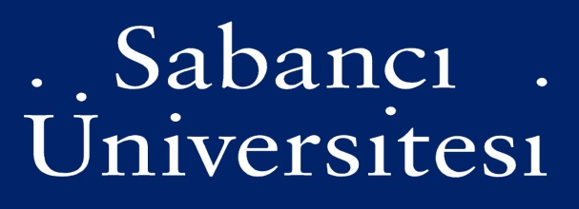

MATH 542-ALGEBRAIC CURVES
SPRING 2021-2022

Instructor: Nurdagül Anbar Meidl
E-mail: nanbar@sabanciuniv.edu
Office: FENS G047
Lectures: Monday: 13:40-16:30 in FENS 2019
Zoom Link for lectures: https://sabanciuniv.zoom.us/j/9466340992
Office Hours: By appointment via Zoom meeting

TEACHING METHOD
Due to pandemic, lectures will be hybrid in the sense that lectures can be both physically and virtually (synchronized fashion) followed. All the lectures will be posted.

TEXTBOOK
We will not have a textbook. However, if you like, you can read the following book.

Algebraic Curves: An Introduction to Algebraic Geometry by William Fulton
COURSE CONTENT
Plane curves, affine and projective varieties, intersection of curves, Bezout's theorem, analysis of singularities, Riemann Roch theorem.

GRADING
3 Homework: %25+%25+%25
Final: %25

EXAM POLICY
There will be three homework during the semester and one final exam. Final exam will be in the form of a written exam, in-person, and on campus. Exam is closed book. This means that during the exam, the use of books, notes, electronic devices (including cell phones, smart watches, calculators, computers etc.), or any other kind of supporting learning material is NOT allowed. A student violating this rule will receive 0 points for that exam.

MAKE-UP EXAMS
If a student misses the exam, then s/he has to have a medical report by Sabancı Medline covering the exam date. Otherwise, it will be counted as “0”. With the valid excuse, contact the instructor immediately explaining your situation, an in-person or online oral makeup exam will be arranged.

